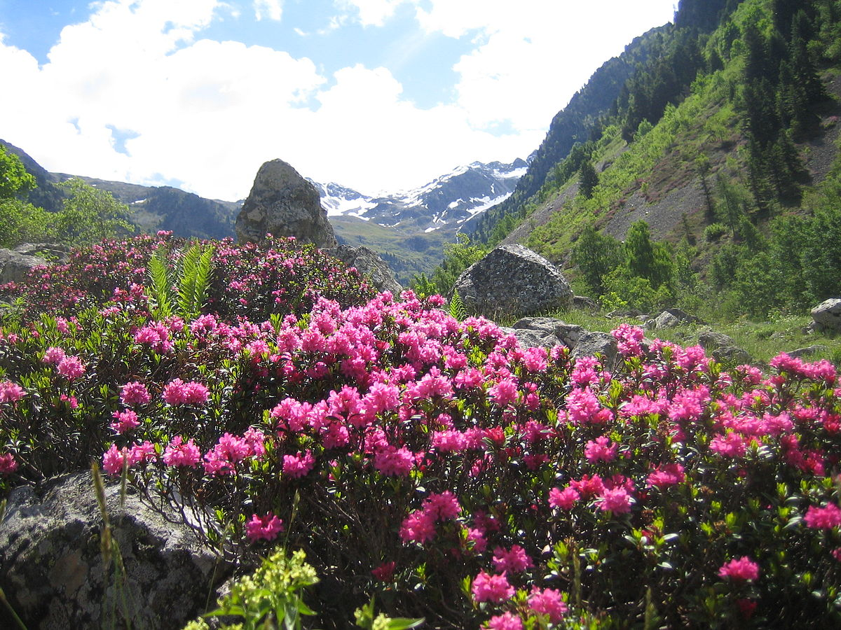

The Rhododendron
A Publication of:
MOUNTAIN STATE COUNCIL OF THE BLIND, INC
131 Heritage Pt.
Morgantown, WV 26505
(773) 572-6304
www.mscbwv.org
AUGUST 2021
Editors: Public Relations Committee

President’s Message
Dear MSCB Members,
To coincide with the hot weather, things are beginning to heat up for the Mountain State Council of the Blind.
Plans are moving along nicely for our upcoming virtual convention. Convention dates are November 5-7. More on that later in this issue.
It is time to submit suggestions for Bylaw changes to be voted on during the business meeting at our convention. Send suggestions to Bylaws committee chair Carol McGhee at
acmcghee@comcast.net
This is your newsletter. Please help us keep it lively and informative. Article submissions are badly needed.
As we approach the Labor Day weekend, I encourage everyone to be vigilant about staying safe.
Until next time, stay well.
Sincerely,
Donna Brown, President

MSCB Moments
This month in MSCB history:
Get Moving Together with MSCB and ACB!
The West Virginia Walkers team is still moving along. Please consider donating to our team. It is not too late. Our goal is to raise at least $4,000. We have raised a bit over $2,700. MSCB receives 50 percent of the funds we raise. A portion of the money we raise from the Walk goes into our scholarship and technology grant funds.
To donate, visit:
https://secure.qgiv.com/event/acbwalk2021/team/874084/

MSCB State Convention Update:
Plans are coming along for our state convention. A schedule is below.
Convention dates: November 5-6
Theme: From the Forest to the Trees
Events schedule:
Friday, November 5
3:00 PM MSCB business meeting
7:00 PM Exhibitor presentations
Saturday, November 6
9:00 Am to 12:00 noon, program speakers
1:00 to 4:00 PM, program speakers
6:00 PM, virtual banquet
Approximately 7:00 PM, auction
Please consider donating auction items. Gift cards, handmade items, food items, and anything that would be easy to ship is suggested.

Tech Talk
Podcasts, What are They?

One of the latest trends in the technology realm is the volume of available podcasts and the variety of topics.
Podcasts are primarily audio presentations or discussions on a given topic. Some podcasts are produced daily, weekly, biweekly, or monthly.
What is nice about podcasts is that one can listen to them on various devices. These include, but are not limited to, computers, smart phones, the Victor Reader Stream, and Echo devices.
ACB has many podcasts available. How can you learn what podcast are available?
Using a computer or Smart Phone, visit:
https://www.acbmedia.org/podcasts/
On the Victor Reader Stream, press the 1 key until you hear podcasts. Press 2 or 8 until you hear title search and press the pound key. Type in ACB followed by the pound key. You will be presented with all podcasts from ACB.
All recorded sessions from the ACB convention are available as podcasts. The best thing about this is that they are free.

ACB Action
Have you heard the latest news? ACB turned 60 on July 7 and is going stronger than ever. A lot has changed over those 60 years. The passing of the ADA in 1990, the 2010 passage of the video and communications accessibility legislation, advances in accessible technology, a bit more financial stability for ACB, just to name a few.
ACB was established in 1961. Some of you may recall what life was like in 1961. Others may have been too young to remember much or weren’t even born yet. So, I thought it would be fitting to see what you know about life in the 1960’s. Take the short quiz below, and you’ll have to read the September issue of the Rhododendron to see how well you did.

What was Life Like in the 1960s Quiz
1. What was the price of a gallon of milk in 1960?
$0.50
$1.20
$2.05
$0.36
2. What was the median cost of a single-family home in the 1960s?
$5,100
$11,900
$22,600
$28,000
3. How many people were age 65 and older in 1960?
40.8 million
25.4 million
64 million
16.2 million
4. How many older adults were living in their own homes in the 1960s?
4.7 million
10 million
13 million
2 million

Important Announcement:
Hello ACB Members,
The strength of ACB is our membership and their commitment to the mission of the organization. We will be finalizing the ACB Committee member rosters for this year, and we would welcome new leaders to join our committees. Please drop me a note at dspoone@acb.org or give me a call at (407) 227-4489 if you would like to learn more about an ACB Committee or would like to express your interest in volunteering for an assignment. The list of ACB Committees can be viewed at https://acb.org/committees.
You’re not alone in your journey through vision loss and blindness. The American Council of the Blind (ACB) welcomes and accepts you. Guided by its members, ACB advocates for equality of people who are blind and visually impaired, inspires community, and connects you with education, resources, and each other to support your independence.
Let’s all work together to fulfill our mission. I look forward to hearing from you.
Dan Spoone
ACB President

Healthy Living

Editor’s note: This information was shared by Larry Johnson, an active member of ACB’s Aging and Vision Loss affiliate (AAVL).
Every year about three hundred and fifty thousand Americans fall and break a hip. Of those, forty per cent end up in a nursing home, and twenty per cent are never able to walk again. The three primary risk factors for falling are poor balance, taking more than four prescription medications, and muscle weakness. Elderly people without these risk factors have a twelve-per-cent chance of falling in a year. Those with all three risk factors have almost a hundred-per-cent chance.

(From The Way We Age Now, by Atul Gawande, in Annals of Medicine (2007) from dayjar)

3 Housekeeping Hints
By Mucie Allred
1. Change with the seasons. Summer and winter used to mean mothballs for those winter woolens like blankets, but modern houses are more airtight.
2. Use a diffuser and essential oil to create a room atmosphere such as flowery for relaxing and earthy for grounding. These being lavender and Vetiver. Scents are interesting to learn. If you do not have a diffuser…satiate a cotton ball and place it in an ideal location like a dish in the entryway or on a windowsill where solar power will bring out the smell.
3. For humans, the ideal inside humidity is 30 to 60 percent, which can be obtained by placing water near a furnace vent to help you monitor the air comfort. I use a wine bottle .

Cook’s Corner
Submission by Donna Brown

It’s time for another smoothie!

Banana Malt
1 To 2 frozen very ripe Bananas
1 To 2 Tbs Malt powder
1 cup Rice Milk (maybe more?)
1 teaspoon Vanilla (optional)
Break or slice the banana into small chunks and put in a
blender. Add malt powder. Add a small amount of the rice
milk and start to blend. Add more rice milk as necessary
until the banana goes from chunks to puree, then blend for
another minute or two before adding the rest of the rice
milk and optional vanilla. If you try to blend all the
ingredients at once you're likely to end up with unblended
banana chunks.
This recipe is a good way to use over-ripe
bananas, which can be peeled and frozen when on your counter for a bit too long.

OATMEAL AND BLUEBERRY SMOOTHIE
1 banana, peeled and cut into chunks
3/4 'cup' blueberries
1/2 'cup' oat milk or regular milk
1/3 'cup' rolled oats
1/2 'cup' ice cubes
2 tablespoons peanut butter
1 tablespoon maple syrup, more or less to taste
Place all ingredients in a blender. Blend on high until smooth, about 30 seconds. Pour into a thermos and seal tightly. Shake before drinking. Makes 1 large serving.

Calendar of Events
August 31: ACB board meeting, 8:00 PM.
September 6: Labor Day.
September 13: It’s 7-up Time!
September 14: 8:00 PM MSCB board meeting, open to all members.
November 5-7: MSCB state convention.

